Register now to attend BVA’s February meeting!

Valuation Issues for the Cannabis & Hemp Industries
Thursday, February 20, 2020
11:45 a.m. - 12:00 p.m. Registration and Networking
12:00 p.m. - 1:45 p.m. Luncheon, Presentation

The Standard Club
320 S. Plymouth Court, 3rd Floor Mezzanine
Chicago, Illinois

Network with colleagues and earn 1.5 CPE.

FEATURED SPEAKER
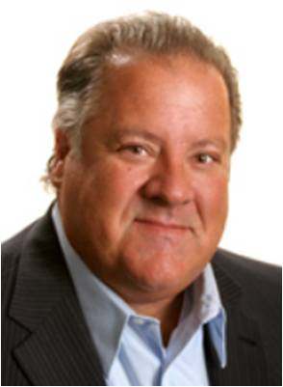
Ron Seigneur, CPA, ABV, ASA, CFF, CGMA
Ron has over 25 years of valuation experience and has been endorsed as an expert witness in several jurisdictions and has served in appointments such as trustee, mediator, arbitrator and special master of the court. Ron is very active nationally as an educator and author of valuation science and has written and taught advanced level valuation courses in several states for the AICPA, NACVA state bar associations and the Environmental Protection Agency.

He is past chair of the AICPA Accredited in Business Valuation committee and NACVA’s Professional Standards Board. He has been an adjunct professor at the University of Denver Sturm College of Law and Daniels College of Business where he has taught leadership, finance and business valuation graduate level courses. Ron is a member of the BVC executive committee of the American Society of Appraisers and is one of 30 individuals who have been inducted into the AICPA ABV Hall of Fame. He is co-author of the 1300+ page treatise on business appraisal titled Financial Valuations: Applications and Models; Reasonable Compensation: Application and Analysis for Appraisal, Tax and Management; and The Cannabis Industry Accounting and Appraisal Guide. Ron also continues to focus attention to tax planning and compliance matters, as well as emphasizing succession and exit planning strategies for Seigneur Gustafson clients and their professional advisors.

Ron is originally from Michigan, but has been living in Golden, Colorado for almost 40 years. In his spare time, Ron and his wife Beverly, enjoy time with their two daughters, Chelsea and Sydney, and his four grandchildren, Zoe, Oliver, Lila, and Remington. He loves golfing, telling jokes and sitting around the fire pit, camping with family and friends, seeing live music, and traveling extensively for work and play.

BA, Hotel Restaurant and Institutional Management, Michigan State University
MBA, Accounting and Corporate Policy, University of Michigan

Ron is dedicated to his profession, as well as his family, and lives life by the motto, “Life is Short…..Play Hard!” Ron can be reached at ron.seigneur@cpavalue.com or 303-980-1111.

